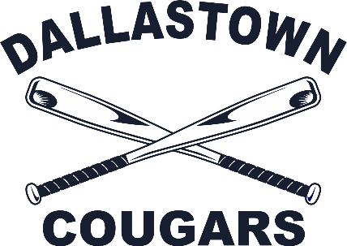 | DALLASTOWN COUGAR LITTLE LEAGUE  TEAM SPONSORSHIP APPLICATION
Local business partner,
Thank for your interest in supporting Dallastown Cougar Little League for the upcoming season! Each year, we solicit partnerships with local businesses in order to help us with operational expenses (field maintenance, rentals, etc) and to avoid passing those costs directly to our players and their families.

A team sponsorship has the following benefits: sponsor name on team jerseys, sponsor team photo plaque, inclusion in sponsor banners at DCLL’s main fields, acknowledgement in our annual yearbook, and interaction on our DCLL social media platforms.

Team sponsorship cost for 2022 is $300.

Community support is a key component in the success of our organization. Thank you for your consideration!

Sponsor Information:
Company Name, as it should appear on shirts (please print clearly):

__________________________________________________________________________________________________
Team/Division/Player Preference* (if any): __________________________________________________
Contact Person: ____________________________________________________________
Address: __________________________________________________________________
City: _________________________________ State ________ Zip ________________
Phone: _________________________________ Email _______________________________________
Website: ____________________________________________________________________________
Authorized Signature: ________________________________________________________________
Please make all checks payable to DCA. Payment may be sent to:
DCA / Attn: Tiffany Carman – 2195 Ridgeview Rd. Dallastown, PA 17313

* Please note that team/player preferences will be honored where possible, but cannot be guaranteed!

